Only questions... for the first to sixth slides (1-6).” programming fundamentals"

**LEC 2**

Example (1): Design an algorithm and the corresponding flowchart for input two number and output their addition (summation).

Example (2): Design an algorithm and the corresponding flowchart for input three number and output their average.

Example (3): Design an algorithm for input two number and computes the arithmetic operators.

Example (4): Write an algorithm and the corresponding flowchart to read length in feet and convert to centimeter.

Example (5): Write an algorithm and the corresponding flowchart to read temperature in Fahrenheit and convert to Celsius.

Example (6): Write an algorithm and the corresponding flowchart to read length of slide and compute area and circumference (perimeter) of square.

Example (7): Write an algorithm and the corresponding flowchart to read number and check if it's even or

Example (8): Write an algorithm and the corresponding flowchart to read number and check if it's positive or negative

Example (9): write an algorithm to find the greater number between two numbers

|  |  |
| --- | --- |
| **Mark** | **Grade** |
| >=85 | Excellent |
| >=75<85 | Very good |
| >=65<75 | Good |
| >=50<65 | Pass |
| <50 | Fail |

Example (10): Write an algorithm enter the marks for student and print the student grade.

WORK SHEET (1)

Q1- Write an algorithm and draw a flowchart to read length in millimeter and convert to centimeter.

Q2- Write an algorithm and draw a flowchart to read length of width and height and compute area and circumference (perimeter) of rectangle.

Q3- Write an algorithm to read length of radios and compute area and circumference (perimeter) of circle.

Q4- Write an algorithm and draw a flowchart that will calculate the roots of a quadratic equation: 𝑎𝑥2 + bx + 𝑐 = 0 Hint: d =√𝑏 2 − 4𝑎𝑐, and the roots are: x1 = (–b + d)/2a and x2 = (–b – d)/2a

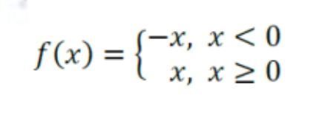Q5- write an algorithm to find the result of equation

Q6- Write algorithm and draw a flowchart to read a city of Iraq as number and print the estimation to refer it. Hint: 1 Baghdad, 2 Basra, 3 Mosul, 4 Erbil

**LEC 3**

Example (1): Write an algorithm and the corresponding flowchart for print numbers between 1 to 5.

Example (2): Write an algorithm and the corresponding flowchart for print even numbers between 0 to 10.

Example (3): Design an algorithm and the corresponding flowchart which asks the user for a number N and prints the sum of the numbers 1 to N?

Example (4): Write algorithm and the corresponding flowchart to read n numbers and print the largest number of them.

Example (5): Write an algorithm and the corresponding flowchart to find 𝑋 𝑌 i.e. power (X, Y).

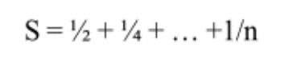Example (6): Write an algorithm with number n as input which calculates following formula:

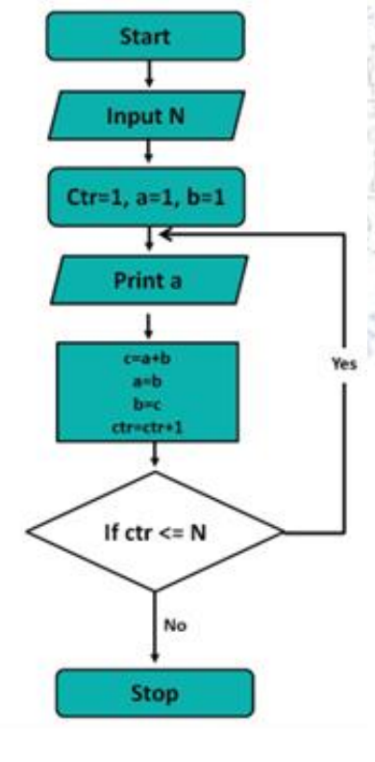Example (7): Draw a Flowchart to generate Fibonacci series as 1,1,2,3,5, 8… where number N as input of terms:

WORK SHEET (2)

Q1- Write an algorithm for print odd numbers between 5 to 20.

Q2- Draw Flowchart for the calculate average from 5 exam scores.

Q3- Write an algorithm and corresponding flowchart to read number and check if it's prime or not prime

Q4- Write an algorithm to find factorial X! Hint: x! = x * x-1 * x-2 * x-3 * ... * 2 * 1

Q5- Write an algorithm and the corresponding flowchart for finding the sum of the numbers 4, 16, 64, 256, 1024, …, n

Q6- Write an algorithm and the corresponding flowchart for reading N numbers and get the summation of negative, the summation of positive numbers and the number in each group

**LEC 4&5**

|  |
| --- |
| **Example: print(function)** |
| print(1,2,3,4)  print(1,2,3,4,sep='*')  print(1,2,3,4,sep='#',end='&') |

|  |
| --- |
| **Example: Python type() function for Numeric Data type** |
| num1 = 5  print(num1, 'is of type', type(num1))  num2 = 2.0  print(num2, 'is of type', type(num2))  num3 = 1+2j  print(num3, 'is of type', type(num3)) |

|  |
| --- |
| **Example: Python Casting for int** |
| x = int(1) # x will be 1  y = int(2.8) # y will be 2  z = int("3") # z will be 3 |

|  |
| --- |
| **Example: Python Casting for float** |
| x = float(1) # x will be 1.0  y = float(2.8) # y will be 2.8  z = float("3") # z will be 3.0  w = float("4.2") # w will be 4.2 |

|  |
| --- |
| **Example: Python Casting for str** |
| x = str("s1") # x will be 's1 '  y = str(2) # y will be '2 '  z = str(3.0) # z will be '3.0' |

|  |
| --- |
| **Example: Python Implicit Type Conversion** |
| a = 123  b = 1.23  c = a + b  print(c)  print(type(c))  a = 123  b = "5"  c = a + b  print(c)  print(type(c)) |

|  |
| --- |
| **Example: Python Implicit Type Conversion** |
| a = 123  b = int("5")  c = a + b  print(c)  print(type(c)) |

|  |
| --- |
| **Example: Arithmetic operators Example: Arithmetic operators** |
| x = 10  y = 4  print ('x + y =', x+y)  print ('x - y =', x-y)  print ('x * y =', x*y)  print ('x / y =', x/y)  print ('x // y =', x//y)  print ('x ** y =', x**y) |

|  |
| --- |
| **Example: Arithmetic operators** |
| x = 10  y = 12  print('x > y is',x>y)  print('x < y is',x<y)  print('x <= y is',x<=y)  print('x >= y is',x>=y)  print('x == y is',x==y)  print('x != y is',x != y) |

Examples of Python Program

Example (1): Write Python Program for input two number and output their addition (summation).

Example (2): Write Python Program for input three number and output their average.

Example (3): Write Python Program for input two number and computes the arithmetic operators

Example (4): Write Python Program to read length in feet and convert to centimeter

Example (5): Write Python Program to read temperature in Fahrenheit and convert to Celsius.

Example (6): Write Python Program to read length of slide and compute area and circumference (perimeter) of square.

**LEC 6**

|  |
| --- |
| **Example: Logical operators** |
| a,b = 5,6  print((a > 2) and (b >= 6))  print(True and False)  print(True or False)  print(not True)  print (not(x < 5 and x < 10)) |

|  |
| --- |
| **Example: Bitwise operators** |
| a,b = 10,4  print("a & b =", a & b)  print("a | b =", a | b)  print("~a =", ~a)  print("a ^ b =", a ^ b)  print(' a>> 2 =', a>> 2)  print(' a<< 1 =', a<< 1) |

|  |
| --- |
| **Example: Identity operators** |
| a,b = 5,5  x2 = 'Hello'  y2 = x2  print(a is not b)  print(x2 is y2) |

|  |
| --- |
| **Example: Membership operators** |
| x = 'Hello world'  v=[1,2,3,4,5]  m=8  print('H' in x)  print('ll' in x)  print('eo' not in x)  print(m in v) |

|  |
| --- |
| **Example: Precedence of Python Operator** |
| a,b,c,d,e = 20,10,15,5,0  e = (a + b) * c / d  print ("e= ", e)  e = ((a + b) * c) / d  print ("e= ", e)  e = (a + b) * (c / d)  print ("e= ", e)  e = a + (b * c) // d;  print ("e= ", e)  m= 10 - 4 * 2  print ("m= ", m)  m= (10 - 4) * 2  print ("m= ", m)  print (2 ** 3 ** 2)  print((2 ** 3) ** 2) |

|  |
| --- |
| **Example: Handling Exceptions with Try/Except** |
| try:  a = 10  b = 0  result = a/b  print(result)  except: ValueError as e:  print(e) |

|  |
| --- |
| **Example: Handling Exceptions with Try/Except** |
| try:  a = 10  b = 0  result = a/b  print(result)  except :  print("Error: b cannot be 0.") |